Document Name | Turbo Ops- SOP- Dispute
Version | 1.3
Date | 10-May-2022
Initiator | V Sathishkumar
Reviewer | Gopa Kumar K P(Zeta), Support Team, Technology Team
Document Owner | Zeta Dispute Ops
Document Approver (Zeta)& | Umesh Bane- Zeta & Kiran Kumar- HDFC

Version Control

Version | Date | Author | Description
1.0 | 10 May 2022 | V Sathishkumar-Zeta | Document creation
1.1 | 08 Aug 2022 | V Sathishkumar-Zeta | Assumptions section updated
1.1 | 08 Aug 2022 | V Sathishkumar-Zeta | Dependency section updated
1.1 | 08 Aug 2022 | V Sathishkumar-Zeta | Reports section tabulated
1.2 | 23 Aug 2022 | V Sathishkumar-Zeta | TAT for FRM referral Updated- across all section
1.2 | 23 Aug 2022 | V Sathishkumar-Zeta | Write Off Section elaborated
1.2 | 23 Aug 2022 | V Sathishkumar-Zeta | Settlement Exceptions- Pro-active Dispute basis Block Code Matrix.
1.3 | 15 Nov 2022 | V Sathishkumar- Zeta | GL Processing steps added.
1.3 | 15 Nov 2022 | V Sathishkumar- Zeta | Provisional/Permanent Credit Detailed for GST reversal basis dispute category added.
1.3 | 15 Nov 2022 | V Sathishkumar- Zeta | Process for 2FA transactions- Points addition POC, Reports requirement point, and documents required section added
1.3 | 21 Nov 2022 | V Sathishkumar-Zeta | CPFIR reporting and Dispute on Unsettled transaction Added

Index
S.I | Section | Description | Page No
1 | 1 | Scope | 3
2 | 1.1 | Objectives, Assumptions and Dependency | 3
3 | 1.2 | Working Hours | 3
4 | 1.3 | Key Stakeholders | 4
5 | 1.4 | Dispute inflow- Overview | 4
6 | 1.5 | Dispute Channels- Options for Dispute Initiation. | 5
7 | 1.6 | Turbo Dispute Process Steps | 5-9
8 | 1.7 | TAT for actioning dispute at Dispute Ops team (Zeta) | 9-11
9 | 1.7.1 | TAT for actioning disputes at Dispute Ops team (Zeta), Support centre (Zeta) | 9-13
10 | 1.8 | Process steps - Handling dispute basis transaction type and Dispute Nature | 13-20
11 | 1.8.1 | ATM Transactions
 |  | 1. ATM Transactions-Cash Not dispensed or Partial Cash not Dispensed
 |  | 2. ATM Withdrawal – Unauthorized
 |  | 3. ATM Withdrawal – Duplicate debit
 |  | Retail Transactions
 | 1.8.2
 |  | 1. Unauthorized Dispute
 |  | 2. Service-related disputes/ Product Not received/Not as described
 |  | 3. Duplicate billing.
 |  | 4. Service not rendered- Failed Transaction.
 |  | 5. Paid by another Means/ Altered Amount.
 |  | 6. Late presentment
 |  | 7. EMI Dispute
 |  | 8. Settlement Exceptions- Pro-active disputes basis Block Code Matrix.
12 | 1.8.3 | Visa Reason Codes used for investigation | 21-22
13 | 1.8.4 | Visa Reason Codes, Member Message Text, Document Indicator | 23
14 | 1.9 | Provisional Credit guidelines. | 24-25
15 | 2 | Write Off scenario | 25-26
 |  | A. Transaction based Write off
 |  | B. Scenario based Write off
16 | 2.1 and 2.1.1 | Fraud Reporting for unauthorized dispute and exception file listing | 26-29
17 | 2.2 | Dispute Life Cycle with time frames | 30
18 | 2.3 | Generic Accounting flow | 31-40
19 | 2.4 | Pre compliance | 41
20 | 2.5 | Good Faith Process | 41-42
21 | 2.6 | Annexures | 42
22 | 2.7 | Zeta Reports | 42
23 | 2.8 | CPFIR reporting- Regulatory requirement | 43-44
23 | 2.9 | Unsettled Transaction- Process | 45
1.0 Scope
The below process outlines the steps or processes to be followed for dispute resolution and management for Visa transactions between Zeta Ops and HDFC Bank.
1.1 Objectives
The objective of this document is to define a robust Dispute ops process for HDFC Turbo Program and Zeta Ops, in coordination with Visa.

- Dispute Channels
- Dispute inflow- Overview.
- Turbo Dispute Process Steps
- Turn Around Time - Actioning dispute at Zeta Dispute Ops team (Internal to Ops)
- Turn Around Time for actioning disputes at Dispute Ops team (Zeta), Support centre (Zeta) and HDFC bank. (Interdepartmental)
- Process steps - Handling dispute basis transaction type and Dispute Nature
- Provisional Credit guidelines.
- Fraud reporting and Exception file listing
- Dispute Life Cycle with time frames
- Accounting entries.
- CPFIR reporting
- Unsettled dispute Processing

Assumptions
- The dispute actions for all disputes (HDFC Offus, HDFC Onus & ATM transactions) shall be regulated through VROL.
- Permanent credit issuance, provisional credit issuance, permanent credit reversal & provisional credit reversals shall ride on the defined process, unless specifically called out in this document. No separate CAD matrix shall be applicable.
- The dispute actions shall be in accordance with the regulations defined in the latest Visa Dispute manuals.
- Account number to be shared by the Bank for Flexcube hand off.
- Any exception to the above process, Zeta team shall refer those details to the bank and obtain approvals.
Dependency
1. Bank
  - Information exchange process between Zeta and HDFC.
  - Dispute accounting entries walkthrough.
  - Confirmations on the dispute notification (Alert) verbiage.
2. Zeta
  - Dispute workflow in operation centre (Provisional credit, write off, Permanent credit, dispute life cycles)
  - GL mapping for all disputed transactions.
  - Dispute Notifications.
1.2 Working Hours

- Office hours are defined as 9 hours between 9:00 am to 6:00 pm during the 5 working days of a week, i.e. from Monday to Friday except for public holidays.

1.3 Key Stakeholder

- Zeta-Dispute Ops
- Zeta-Support Centre
- HDFC Bank Ops Center

1.4 Dispute inflow- Overview.
The support team with the help of Dispute Ops will manage the overall dispute lifecycle for the transactions.

Steps | Process | Team
Step 1 | Support centre to collate the Customer complaints to raise dispute in the support centre UI and assign to Ops centre for Dispute investigations. | Support Centre
Step 2 | Support centre to share the details in MIS format for Dispute Ops team. Refer Annexure | Support Centre
Step 3 | Dispute Ops to raise the Provisional/ Permanent credit, Fraud referral, write off and chargeback with the network over VROL portal and manage investigation.  Supporting documents for the disputes shall be taken from Freshdesk and action the case basis the dispute nature. The documentation requirement shall be aligned to the Visa Network rules and regulations on Dispute management. | Zeta Dispute Ops centre
Step 4 | Dispute Ops and Support centre (customer contact on compelling documents/information as applicable) shall manage Representment and Pre arbitration as per association guidelines including No response for Verification on merchant documents. | Zeta Dispute Ops, Support centre
Step 5 | Final Level of investigation approach at the Arbitration life cycle shall be taken basis the merit of the case and if required (on a need basis) the case can be referred to HDFC bank and take final call before arbitration filing/ response. | Zeta Dispute Ops and HDFC bank

Section 1.5 Dispute Channels- Options for Dispute Initiation.

Customers shall dispute the transactions via Turbo App or Customers can raise a dispute with the existing HDFC bank channels. Below flow depicts how a dispute can flow into the Support centre from Customer and HDFC bank channels. Bank channel is tentative and final flow yet to be decided.
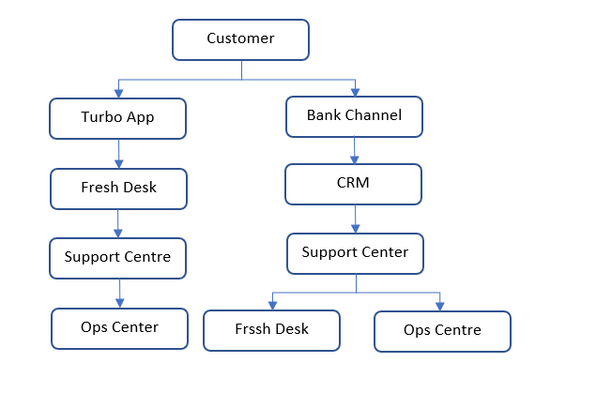
1.6 Turbo Dispute Process Steps

- Process Steps for dispute query raised in the Turbo App.

Step 1: User (Customer) shall have option to raise query inside the Turbo App. In the turbo, user can either user query section or select the respective transaction to raise the dispute query which gets into Freshdesk upon submission by the user. The query raised by the user shall automatically route to the fresh desk and create Ticket in the fresh desk system.

Step 2: On raising the query in the App, the user shall have the reference ID generated in the App as a reference to the customer.

Step 3: On receipt of query in the Fresh desk ticket system, the Support centre team shall evaluate the query and if it pertains to dispute, support centre associate shall verify if all the details in accordance with the dispute nature are available. If available, the support centre associate shall raise dispute in support centre UI and assign to the Ops centre and update the CRM application with the details and assign to Ops. Subsequently, support centre agent shall create a child ticket in the fresh desk system and assign it to the ops centre for updating the status.

Step 4: If the details are not available, the support centre agent shall have the required details sent to the customer via App (help centre) and push the required details through notification to the customer.

Step 5: Once the notification is pushed, the support centre associate shall call the customer and inform the requirement with the user and request the user to share the details via app.

Step 6: Support centre shall wait for 10 days and validate if the details are available to raise dispute.

Step 7: If the details are available, support Centre associates shall raise dispute in their User Interface and assign it to the Ops team for action.

Step 8: If the details are not available, first reminder to be sent to the user on 10th day and call the customer to share the required details.

Step 9: If the customer has still not responded after the waiting period, support centre shall trigger second reminder on 20th day.

Step 10: If customer has still not responded on 45th day, Support centre shall send the closure response in the app and close the ticket.

- Process steps for dispute query raised in the bank Channels.

Step 1: User (Customer) shall raise the dispute to the bank existing channels. ( Ex: Email, Branch banking, Phone banking, etc..)

Step 2: The banks associate on receiving the query from customer, shall educate the user to use the app for raising the dispute. If customer is insisting to raise dispute, HDFC team shall use the CRM next and assign to the Zeta Support team. Documents received from the customer shall also be uploaded in the CRM next application.

Step 3: On receiving the dispute in CRM next application, the support centre user shall have the details received in the CRM next and raise fresh desk ticket.

Step 4: The support centre associate shall validate the disputes prerequisite as per the dispute nature.

Step 5: If all the dispute details are available, the support centre associate shall raise dispute in support centre UI , assign to the Ops centre and update the details in CRM next. Also support centre agent shall create a child ticket in the fresh desk system and assign it to the ops centre for updating the status.

Step 6: If the details are not available, the support centre agent shall cure the request with the customer with pre-defined TAT for intimation and follow-ups

Step 7: If the details are available, support Centre associate shall raise dispute in their UI and assign it to Ops team for actioning.

Step 8: Support centre shall wait for 10 days and validate if the details are available to raise dispute.

Step 9: If the details are available, support Centre associate shall raise dispute in their UI and Assign it to Ops team for actioning.

Step 10: If the details are not available, first reminder to be sent to the user on 10th day and call the customer to share the required details.

Step 11: If the customer has still not responded after the waiting period, support centre shall trigger second reminder on 20th day.

Step 12: If customer has still not responded on 45th day, Support centre shall send the closure response in the app and close the ticket.

Process flow in Ops centre
Step 1: Dispute creation is done by the agent in the support centre and assigns the dispute to Ops centre.
Step 2: The Maker in the Ops centre, starts to action the case basis the dispute nature. The maker evaluates if all the pre-requisites are available to proceed with the investigation.
Step 3: If all the details are available, the maker initiates dispute credit (provisional or Permanent credit) basis dispute nature and selects the resolution for the dispute.
Step 4: The maker can either take write off basis banks Policy, raise chargeback/ Pre compliance or Refer to FRM as one of the resolution processes.
Step 5: Once resolution is selected, the maker action gets completed. The maker shall provide the details in the notes section on why the resolution is being recommend for the dispute raised by the user and the dispute gets assigned to the checker.
Step 6: The checker logs into the Ops centre UI and validates the maker action. The Checker either approve or rejects the action taken by the maker.
Step 7: The check shall validate the maker action from the base dispute nature and confirm to the maker to perform the action. If all the details mentioned by the maker are valid, the checker approves the maker action in the workflow.
Step 8: Once the checker approves the maker actions, the system automatically assigns the task to the maker.
Step 9: The maker takes the action for completion outside the workflow.
Use case 1: If the chargeback decision is taken by the maker and Checker approves the same, then the maker would go the network UI and raise chargeback with what checker has approved in the workflow system.
Use case 2: If the Write off decision is taken by the maker and Checker approves the same, then the maker would prepare the write off file and then sends it to the Banks team on monthly basis for passing the entries in the respective GLs.
Use case 3: If the FRM referral decision is taken by the maker and Checker approves the same, then the maker would prepare the FRM referral file and then sends it to the Banks team on CRM Next on daily basis.
Step 10: If the dispute prerequisite is not available, Ops centre shall update the child ticket created by the support team in the freshdesk with the requirements to be asked with the customer and assign it back to the support centre.

Step 11: The Child ticket also to be updated with priority status. The status update shall help the ageing cases prioritized by the support centre.

Step 12: The support centre shall push the requirements via help centre and reaches the user. The support centre agent shall also call the customer to share the details and await confirmation.

Step 13: The agent shall do the follow-up with the customer and send the reminders as per the TAT mentioned above.

Step 14: If response received for the request, the agent shall update the child ticket and reassign the ticket to Ops.

Step 15: If no response received after reminders, the support centre shall inform the Ops team via child ticket details. Ops team shall update the dispute status in the dispute Workflow and close the dispute.

Step 16: Dispute Ops team raises a chargeback on request from the Support centre to the acquiring bank within T+ 2 working days from the date of dispute receipt with the dispute Ops Team. If the Transactions are nearing the time frame for the association, the disputes shall be actioned on a best effort basis.

Step 17: Disputes in Visa are classified into allocation and Collaboration. Dispute shall be further investigated based on schemes laid guidelines.

Allocation – A workflow where VROL automatically determines financial liability for the dispute. Fraud and Authorization disputes follow this workflow.

Collaboration – A workflow where VROL does not automatically determine liability. Consumer and Processing Error disputes follow this workflow.

Step 18: Disputes processed with a Fraud or Authorization dispute category follow the allocation process.
In this workflow

- Ops Associate shall raise the dispute (Chargeback) in the VROL system directly by selecting the respective transaction using VROL Transaction Inquiry screen.
- Acquirers can respond to disputes using a Pre-Arbitration questionnaire within 30 days beyond which chargeback is deemed to be won.
- Issuers can accept the Pre arb or choose to respond to the Pre-Arbitration using a Pre-Arbitration Response questionnaire.
- If the dispute is not resolved after these steps, the Acquirer can initiate Case filing.
- In case the result is not in favour of Acquirer bank, it will have to bear the Arbitration fee as a penalty and disputed amount to Issuer Bank and vice versa.

Step 19: Disputes processed with a Consumer or Processing Error category follow the collaboration process.

In this workflow:

- Ops Associate shall raise the dispute (Chargeback) in the VROL system directly by selecting the respective transaction using VROL Transaction Inquiry screen.
- Acquirers can respond to disputes using a Dispute Response (Representment) questionnaire within 30 days beyond which chargeback is deemed to be won.
- Issuers can continue the dispute using a Pre-Arbitration questionnaire.
- Acquirers can respond to the Pre-Arbitration using a Pre-Arbitration Response questionnaire.
- If the dispute is not resolved after these steps, the issuer can initiate Case Filing.
- In case the result is not in favour of Acquirer bank, it will have to bear the Arbitration fee as a penalty and disputed amount to Issuer Bank and vice versa.

- Step 20: High level Dispute resolution flowchart for Allocation and Collaboration module.

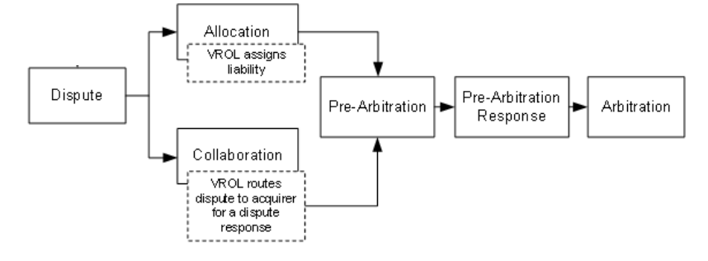
1.7 TAT for actioning dispute at Dispute Ops team (Zeta)

Steps | Process | Team Responsible | Dispute Stage | TAT (Working days)
Chargeback/ Write Off decision and Dispute rejects | Dispute ops to Raise chargeback/ Write Off decision and Dispute rejects for the dispute complaints received from the customer via Support Centre. | Dispute Ops Team | Dispute assigned to Ops centre. | 2 days.
FRM referral | Dispute ops to refer to FRM team for investigation on the complaints received from the customer via Support Centre on the same day if dispute received with Ops centre before 3 PM.  If dispute received after 3 PM, shall be referred to FRM investigation on the next day.  For settled / unsettled transactions – FRM referral guidelines timings to be followed as mentioned above  For Unsettled disputes- FRM referral shall be done from CS team for cancellation of transaction and timings for referral shall be followed as mentioned above | Customer support team and Zeta Ops team  Customer support team | Dispute assigned to Ops centre. | Same day
Incoming Pre arbitration | Dispute Ops team to check the Pre arbitration and action the case. Either accept Pre-arbitration or Send Verification letter to customer. | Dispute Ops Team | Pre-Arbitration received in Association UI. | 3 days
Verification correspondence to Customer | Dispute Ops team shall assign the Child ticket to the support centre to send the merchant documents to the customer for progressive dispute confirmation. | Support Centre | Document Intimation received at Support centre from Ops centre. | 1 Day.
Verification correspondence response from customer | Support team shall check for the response from customer for the merchant documents sent for progressive dispute confirmation. | Support Centre | Document details request sent to customer. | 7 days
Incoming Verification letter response action. | The Support centre shall check the customer’s response for the merchant documents/information sent for verification. Post receiving customer response, the support centre shall route the child ticket to Dispute Ops team to validate and action the pre-arbitration. | Support Centre | Document Intimation received at Support centre from Customer. | 1 day.
Pre arbitration Decline/Acceptance | Dispute Ops team shall validate the response from Customer and either Decline / Accept the Pre arbitration | Dispute Ops Team | Document and Intimation received at Ops centre from Support centre. | 5 Days
Incoming Arbitration | Dispute Ops team to check the Incoming arbitration and action the case. Either Pre-accept or Decline arbitration. | Dispute Ops team. | Arbitration received in Association UI. | 2 Days

Dispute TAT- Collaboration Module

Steps | Process | Team Responsible | Dispute Stage | TAT (Working days)
Chargeback/ FRM referral/ Write Off decision and Dispute rejects | Dispute ops to Raise chargeback/FRM referral/ Write Off decision and Dispute rejects for the dispute complaints received from the customer via Support Centre. | Dispute Ops Team | Dispute assigned to Ops centre. | 2 Days
Incoming Representment | Dispute Ops team to check the representment and action the case. Either accept representment or send Verification letter to customer. | Dispute Ops team | Representment received in Association UI. | 3 Days
Verification correspondence to Customer | Dispute Ops team shall assign the Child ticket to the support centre to send the merchant documents to the customer for progressive dispute confirmation. | Support Centre | Document Intimation received at Support centre from Ops centre. | 1 Day.
Verification correspondence response from customer | Support team shall check for the response from customer for the merchant documents sent for progressive dispute confirmation. | Support Centre | Document details request sent to customer. | 7 days
Incoming Verification letter response action. | The Support centre shall check the customer’s response for the merchant documents/information sent for verification. Post receiving customer response, the support centre shall route the child ticket to Dispute Ops team to validate and action the Re-presentment. | Support Centre | Document Intimation received at Support centre from Customer. | 1 Day.
Outgoing Pre- arbitration | Dispute Ops team to check the response from the customer and action the case.  Raise pre-arbitration in the system | Dispute Ops Team | Document Intimation received at Dispute centre from Support centre. | 5 Days
Response for Outgoing pre arbitration (Accept/Decline)  Outgoing Arbitration | Dispute Ops team shall check for the response for Outgoing pre-arbitration and either close the dispute or raise arbitration. | Dispute Ops Team | Pre Arb-Response received in Association UI. | 3 Days

1.7.1 TAT for actioning dispute at Dispute Ops team (Zeta), Support centre and HDFC bank.

Steps | Process | Team Responsible | Dispute State | TAT (Working days)
Chargeback additional information/ Document requirement | Support centre shall send the notification and parallelly call and obtain the missing Information/ documents from customer for first level of investigation. | Support centre | Dispute assigned to support centre agent from Fresh desk system | 2 Days
Incoming Pre arbitration & Representment- Verification letter | The Dispute Ops team shall validate the Incoming pre- arbitration/re-presentment and either accept or send the documents to the customer for progressive dispute confirmation. | Dispute Ops | Pre Arb/ Representment received in association UI. | 3 Days
 | Dispute Ops team shall request the support centre to send the documents to customer and track the response from customer. | Support Centre | Document Intimation received at Support centre from Ops centre. | 1 Day
 | Support centre team shall track for response.  If customer does not respond within First level) and Second level TAT days, reminder letter shall be sent | Support centre | Support centre to track for response from the date of first and Second Correspondence sent. | 10 Days First level  &  7 Days Second level
 | If no response received for the reminder correspondence, then Support team shall move the case to Dispute Ops stating no response received. | Support centre | Intimation received at support centre from customer. | 1 Day
 | Dispute Ops team shall close the dispute post confirmation from HDFC Team Nodal Officer and reverse the provisional credit to the customer. | Dispute Ops | Response received from HDFC Team Nodal Officer Team | 1 Day
 | If a response is received, the support team shall move the case to Dispute Team for action. Dispute ops team shall act on the basis the response received. | Support centre | Intimation received at Ops centre from Support centre. | 1 Day
Incoming Arbitration | Dispute Ops team to check the Incoming arbitration and action the case. Either Pre-accept or Decline arbitration. | Dispute Ops Team. | Arbitration received in Association UI. | 2 Days
Outgoing Arbitration | Dispute Ops team to check the Outgoing pre- arbitration response and action the case. Either Pre-accept or Initiate arbitration. | Dispute Ops Team | Pre-Arbitration response received in Association UI. | 3 Days
Unauthorized Secure Dispute referral to HDFC Bank Credit Intelligence and Control Team for investigation. | Support centre team checks the dispute and arranges to dispute in the UI and assign to Ops centre.  Ops centre to send the Unauthorized secured dispute to HDFC bank Credit Intelligence and Control team for investigation. | Support centre and Dispute Ops | Dispute received in support centre.  Dispute received in Ops centre. | 1 Day  1 Same Day
Response from HDFC Bank | Post investigation completion, HDFC team shall confirm the final action to be taken | HDFC bank and Dispute Ops | Dispute assigned to HDFC Credit Intelligence and Control centre in CRM Next application. | 9 Days

1.8 Process steps - Handling dispute basis transaction type and Dispute Nature
1.8.1- ATM Transactions
- ATM Withdrawal – Cash Not dispensed or Partial Cash not Dispensed.
  - When an ATM transaction is disputed as Cash not dispensed or partial cash dispensed, the Support team associate shall inform the customer that provisional credit will get effected to the card account in 02 working days and Turnaround Time (TAT) for investigation as per the network guidelines.
  - Zeta Ops shall provide Provisional/ Permanent credit by debiting the Internal AR account and credit customer account and assign the dispute case to the Dispute Ops team.

- ATM Withdrawal – Unauthorized

  - Support team to probe the customer to confirm whether card is in customer's possession or lost and adds the entry into dispute. If it is a lost card scenario, the Support team officer blocks the card number, and advises customers to log police complaint and submit the customer dispute form (CDF).
  - Dispute Ops team Shall refer the dispute to Banks FRM team and as the ATM transaction can be completed only with the PIN (Personal Identification Number) which is confidential and known only to the customer and not to be shared with anyone.
  - Banks Referral Shall be done on the same day if Dispute received before 3 PM from support centre to Ops and the next day for the disputes received after 3 PM.
  - If Chargeback rights exists, then a permanent credit shall be provided to the customer.
  - In no chargeback rights exists, Dispute Op shall provide Provisional credit and then refer to FRM team for investigation.
  - Basis FRM team Investigation Outcome, a Provisional credit reversal or Permanent credit shall be provided to the customer account.
  - Zeta Ops shall provide Provisional/ Permanent credit by debiting the Internal AR account and credit customer account.

- ATM Withdrawal – Duplicate debit

  - The Support team associate shall inform the customer that provisional credit will get effected to the card account in 02 working days and Turnaround Time (TAT) as per association guidelines.
  - Zeta Ops shall provide temporary credit by debiting the Internal AR account and credit customer account and assign the dispute case to Dispute Ops team.

1.8.2- Retail Transaction
- Unauthorized Dispute

  - Basis customer confirming transaction not being done by him/her, Support centre officer advises and seeks confirmation from customer to block the credit card to secure the customer from any further unauthorized transactions.
  - Wherever the customer denies blocking of the card number, the officer will register the transaction dispute in the Dispute App and reiterate the requirement of the card block to avoid any further misuse and get customer consent and block the card.
  - Post getting confirmation from the customer, the support centre agent blocks the card and initiates dispute in the support centre UI and assigns to dispute Ops centre for actioning.

      - Process for 2FA transactions.

    - Dispute centre associate checks if the transaction is 2FA and if the transaction is of 2FA, the ops centre maker provides provisional credit and refers the transaction to Bank Credit Intelligence and Control team for further investigation.
    - The referral to Banks Credit Intelligence and Control team shall be done via CRM next application.
    - The dispute assigned to Ops centre from the Support centre within 3 Pm on the same day shall be referred to Bank on the same Day and dispute received post 3 Pm shall be referred on the next day.
    - Dispute Ops shall process the Fraud reporting and exception file listing before referring the case to HDFC Credit Intelligence and Control team.
    - Provisional credit shall be provided to all the secured disputes and where there are no chargeback rights available.
    - HDFC bank shall provide response for all the referred cases within T+9 days.
    - The banks shall confirm on the decision of either making Provisional credit as Permanent or reverse the provisional credit.
    - Cases where Provisional credit are made permanent, Zeta Team shares Auto GL hands off to banks team.
    - For the above points, action (Providing permanent Credit) at zeta ops end shall be taken post confirmation from HDFC CIC team via Excel only and Not basis CRM response updated.
    - Bank Internal Operations team shall pass the knock off entry and resolve the exceptions in AR.
    - The RBS and all other reporting shall be done by the bank without any involvement of Zeta basis the details available in the CRM.
    - Documents required summary for referring.

S.no | Scenarios for referring to HDFC Team | Dispute rights | Documents required while referring
1 | Un-authorized Secure dispute- 2 FA TXN | No | A. Customer compliant in any form-  Ex:  1. Query received in App.  2. Cm email query to Bank  3. CM called Call centre of Zeta. Date and time stamp certification.  Etc...  or  Customer declaration form.  B. For International TXNs- Police complaint and Driving license.
2 | Un-authorized Secure dispute- Non 2 FA TXN | No | A. Customer compliant in any form-  Ex:  1. Query received in App.  2. Cm email query to Bank  3. CM called Call centre of Zeta. Date and time stamp certification.  Etc...  or  Customer declaration form.  B. For International TXNs- Police complaint and Driving license.

Point Of Contact details
Team | Contact Type | Name | Contact No. | Email ID
Zeta Banking Ops | L1 | V Sathishkumar | 9916158583 | sathishv@zeta.tech
Zeta Banking Ops | L2 | Gopa Kumar | 8939900879 | gopakumark@zeta.tech
Zeta Banking Ops | L3 | Umesh | 9819463521 | umesh@zeta.tech

      - Process for Non- 2FA transactions

    - For Non-2FA transactions, the Dispute ops team shall proceed with the dispute investigation as per the association guidelines and resolve the disputes as per the association TAT.
    - Dispute Ops shall process the chargeback in VROL and arrange to do Fraud report and exception file listing at the time of initiating the dispute in VROL.
    - Permanent credit shall be provided for all the disputes wherever we have chargeback rights on the same day of the dispute raised within 2 working days.
    - Disputes received after 115th day are actioned on the best-efforts basis and if disputes are not recoverable, then those disputes shall be referred to the bank for further proceedings.
    - If a customer disputes multiple transaction under Unauthorized dispute category at single instance, Dispute Ops team shall action the disputes based on the highest value to comply with the FNS condition (Fraud Notification service). The total number of Transactions disputed are capped at 35 for Visa disputes.
      - Example: If a customer disputes 40 transactions of value ranging from 100 to 115, then disputes investigation shall be carried out as shown below. The remaining transaction shall be taken based on the outcome of the investigation of 35 transactions. If all the transactions are won in favour of the customer, the 36th transaction shall be made permanent by taking a write off and parallelly refer it to bank's Risk Credit Intelligence and Control team for investigation and their feedback.
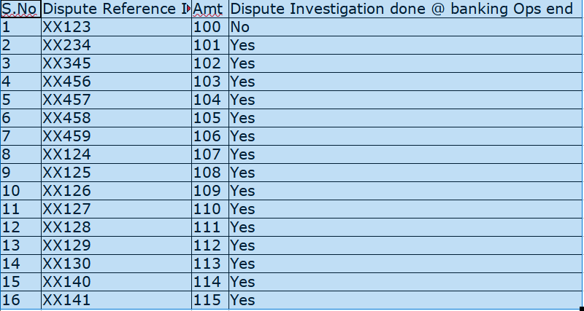
- Wherever disputes may be of the type where the merchant documents evidence the disputed charge were due to the T&C agreement accepted by the customer during the transaction execution (May be applicable for International Transactions alone), Zeta Ops team shall certify on behalf of the customer for the progressive dispute and proceed with the dispute forward. Example: Netflix, Amazon etc…
- Any compelling documents shared by the merchant for the dispute raised shall be forwarded to the support centre team to share the same with the customer.
- Support centre shall connect with the customer and request customer to share the response for progressive dispute.

- Service-related disputes/ Product Not received/Not as described.

  - Customer disputes pertaining to service/ Product not received shall be checked if the pre-requisite as per network guidelines are available. If the required details as per the association guidelines are not available at Freshdesk, the Support centre associate shall send the requirement to customer via Help desk and parallelly call back the customer and get all the required details as per the association guidelines.

  - For details where we don’t have any information, the support team shall not initiate the dispute.

  - Once the required details are obtained, the Support team shall inform the customer to provide document evidence to support the customer dispute during the investigation process and subsequently raise a dispute and provide Provisional credit subject to availability of all information/documentation from the customer.

  - In the absence of documentation/details from the customer, investigation may be initiated on a case-to-case basis (value to transaction/customer profile etc) as a service gesture, with clear information to the customer that the supporting artifacts are deficient and hence provisional credit shall not be issued.

- Duplicate billing.

  - Customer disputes pertaining to duplicate billing shall be checked if the pre-requisite as per network guidelines are available.

  - The Support centre associate shall check if the details of the actual transaction accepted, and disputed transaction are available. If the details are not available, support centre shall get all the required details for the Dispute Ops team to process the dispute investigation and initiate provisional credit to the customer card account.

- Service not rendered- Failed Transaction.

  - Customer disputes pertaining to a failed transaction shall fall under the service not rendered dispute category.

  - All the prerequisites for service-related disputes shall be checked before dispute initiation by the support centre.

  - If the required details as per the association guidelines are not available at Freshdesk, the Support centre associate shall call back the customer and get all the required details as per the association guidelines.

  - For details where we don’t have any information, the support team shall not initiate the dispute.

  - Once the required details are obtained, the Support team shall inform the customer to provide document evidence to support the customer dispute during the investigation process and subsequently raise a dispute and provide Provisional credit subject to availability of all information/documentation from the customer.

  - In the absence of documentation from the customer, investigation may be initiated on a case-to-case basis (value to transaction/customer profile etc) as a service gesture, with clear information to the customer that the supporting artifacts are deficient and hence provisional credit shall not be issued.

- Paid by another Means/ Altered Amount.

  - Customer disputes pertaining to Paid by other means/ Altered amount shall require the documentary evidence to support the chargeback.

  - If the required details are not available at Freshdesk, the Support centre associate shall call back the customer and get all the required details as per the association guidelines.

  - Once the required details are obtained, the Support team shall inform the customer to provide document evidence to support the customer dispute during the investigation process and subsequently raise a dispute and assign to dispute ops centre for investigation.

  - Dispute ops team shall proceed with Provisional credit subject to availability of all information/documentation from the customer.

  - In the absence of documentation from the customer, investigation might be initiated on a case-to-case basis (value to transaction/customer profile etc) as a service gesture, with clear information to the customer that the supporting artifacts are deficient and hence provisional credit shall not be issued.
- Late Presentment.

  - Bank Initiated Dispute.

    - When a Settlement received late and could not be posted due to technical reason like Account in Blocked status, Card closed, then Zeta dispute Ops team shall initiate technical chargeback basis the exception report available.

    - Dispute shall be taken forward as per the network guidelines and resolved.

  - Customer Initiated Dispute.

    - When a customer initiates the dispute which are presented late, the dispute shall be actioned with the best possible reason code to recover the amount to the customer.
      - For example,
        - <Customer>: Dispute received as transaction Not authorized and settled late.
        - <Solution>: Dispute Ops team shall go in for Late presentment instead of unauthorized reason code as the acquirer cannot technically win the case against the issuer.
- Dispute on EMI.

    - For disputes raised on a transaction which is converted to EMI and when a customer disputes, Zeta Ops team shall process the dispute based on the actual nature of dispute on the original Transaction. All the prerequisites shall be obtained by the support centre before proceeding the dispute investigation. However, the loan closure shall happen only after the completion of the dispute investigation.
    - Completion means dispute shall get closed in favor or against. Loan closure shall happen only where the customer wins the case.

- Settlement Exceptions- Pro-active disputes basis Block Code Matrix.

- As part of the settlement exception basis the block code matrix shared by Bank, Zeta Ops team shall raise dispute basis the technical dispute rights available.

- Zeta Ops team shall raise disputes like Late presentment, No Authorization obtained chargeback to recover the amount.

- The block mentioned are as per the existing construct of the bank and this may vary basis the Internal system Build in Zeta. Once the Block development is done, we shall have the respective Code mapped against the Banks Code.

- The block code shared by the Bank to be monitored are mentioned below.

Details shared by the Bank

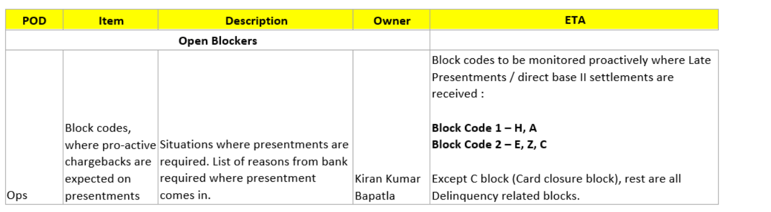

- 1.8.3 - Visa Reason Codes used for investigation

Category (Fraud) | Classification of Category | Timeframe (Days)
10.1 | EMV Liability Shift Counterfeit Fraud  Counterfeit chip card was used at a POS system where the transaction was not processed as a chip transaction | 120 days
10.2 | EMV Liability Shift Non-Counterfeit Fraud  In a card-present transaction, either: Chip-reading terminal was not used; or a chip-reading terminal but the machine was not PIN compliant. | 120 days
10.3 | Other Fraud: Card-Present Environment / Condition  Fraudulent transaction made using physical card using an stolen account number Classification of Category | 120 days
10.4 | Card-absent Environment / Condition  An unauthorized transaction occurred without the physical card involved. In a card-absent environment (online/phone/direct mail sales, etc.), an unauthorized claim was processed | 120 days
10.5 | Visa Fraud Monitoring Program  Transaction flagged by Visa's Fraud Monitoring Program. Visa identifies and informs Issuer as potentially fraudulent transaction. | 120 days

Category (Authorization) | Classification of Category | Timeframe (Days)
11.1 | Card Recovery Bulletin  Transaction settled in an account number listed in the Card Recovery Bulletin | 75
11.2 | Declined Authorization  Authorization was declined, but the transaction was processed in card account. | 75
11.3 | No Authorization  Transaction processed without any attempt for authorization; Authorization requested after the fact and/or settled for a different amount. | 75
Category (Processing  Error) | Classification of Category | Timeframe (Days)
12.2 | Incorrect Transaction Code  Merchant processed a debit instead of a credit;Credit instead of reversal | 120 days
12.3 | Incorrect Currency  Transaction currency differs from the currency transmitted through Visa;  Cardholder was not advised or did not agree for Dynamic Currency Conversion (DCC) | 120 days
12.4 | Incorrect Account Number  Transaction processed to an incorrect account number; Adjustment was processed more than 45 days from transaction date  Adjustment was posted to a Closed or non-sufficient funds account more than 10 days after the transaction date Cardholder disputes the validity of the adjustment. | 120 days
12.5 | Incorrect Amount  The amount in the authorization does not match the amount from the transaction.  Transaction amount was changed without the cardholder's consent. | 120 days
12.6 | Duplicate Processing / Paid by Other Means  A single transaction was processed two or more times;Card transaction was processed but cardholder paid for the same merchandise or service by other means such as by cash / through other card | 120 days
12.7 | Invalid Data  Authorization request submitted with an incorrect date, MCC, merchant type indicator, country code, and other required fields, etc. | 75 days

Category (Service) | Classification of Category | Timeframe (Days)
13.2 | Cancelled Recurring Transaction  Cardholder cancelled payment for subscription; Cardholder/issuing bank cancelled the account; Transaction processed post card account closure. | 120 days
13.3 | Not as Described or Defective Merchandise / Services  Goods / services were defective or not as described to the transaction | 120 days
13.4 | Counterfeit Merchandise  The merchandise was identified as counterfeit by the owner of the intellectual property, a government agency, or a neutral third-party expert. | 120 days
13.5 | Misrepresentation  Cardholder claims a purchased item or service was misrepresented and alleges false advertising. | 120 days
13.6 | Credit Not Processed  Cardholder claims a credit was due but never processed. | 120 days
13.7 | Cancelled Merchandise / Services  Cardholder cancelled services / returned products, but no refund processed as per return/refund policy | 120 days
13.8 | Original Credit Transaction Not Accepted  A voided transaction receipt was not processed (applies to Europe) | 120 days
13.9 | Non-Receipt of Cash or Load Transaction Value  Cardholders did not receive the full cash withdrawal at an ATM. | 120 days

1.8.4 - Visa Reason Codes, Member Message Text, Document Indicator used by Zeta Ops for dispute investigation.
Reason Code | Description | Classification | Dispute Category | Doc Indicator | Member Message Text
10.1 | EMV Liability Shift Counterfeit Fraud | Allocation | Fraud | 1 | EMV Liability Shift Counterfeit Fraud
10.2 | EMV Liability Shift Non-Counterfeit Fraud | Allocation | Fraud | 1 | EMV Liability Shift Non-Counterfeit Fraud
10.3 | Card-Present Environment | Allocation | Fraud | 1 | UNAUTHORISED TRNX REF DOCS
10.4 | Other Fraud: Card-absent Environment | Allocation | Fraud | 1 | UNAUTHORISED TRNX REF DOCS
10.5 | Visa Fraud Monitoring Program | Allocation | Fraud | 1 | Visa Fraud Monitoring Program
11.1 | Card Recovery Bulletin | Allocation | Authorization | 0 | Card Recovery Bulletin
11.2 | Declined Authorization | Allocation | Authorization | 0 | Declined authorization
11.3 | No Authorization | Allocation | Authorization | 0 | No Authorization
12.2 | Incorrect Transaction Code | Collaboration | Processing errors | 1 | CREDIT INSTEAD OF REVERSAL
12.3 | Incorrect Currency | Collaboration | Processing errors | 1 | Incorrect Currency xxx
12.4 | Incorrect Account Number | Collaboration | Processing errors | 1 | Incorrect Account Number XXXX
12.5 | Incorrect Amount | Collaboration | Processing errors | 1 | TRAN AMT XXXX NOT XXXX
12.6 | Duplicate Processing / Paid by Other Means | Collaboration | Processing errors | 1 | PAID BY other ARN 74056631358135764728038  PAID BY OTHER CARD  PAID BY CASH
12.7 | Invalid Data | Collaboration | Processing errors | 0 | Invalid Data
13.1 | Service Not rendered/ Godds Not received | Collaboration | Services | 1 | SERVICES NOT RENDERED 11252021/ GOODS NOT RECEIVED
13.2 | Cancelled Recurring Transaction | Collaboration | Services | 1 | Canceled Recurring Transaction DDMMYY
13.3 | Not as Described or Defective Merchandise / Services | Collaboration | Services | 1 | NOT AS DESCRIBED  DEFECTIVE MERCHANDISE
13.4 | Counterfeit Merchandise | Collaboration | Services | 1 | Counterfeit Merchandise DDMMYY
13.5 | Misrepresentation | Collaboration | Services | 1 | Fee Text
13.6 | Credit Not Processed | Collaboration | Services | 1 | CREDIT NOT PROCESSED
13.7 | Cancelled Merchandise / Services | Collaboration | Services | 1 | Cancelled Services 122621  TIMESHARE CANCELLATION 123121
13.8 | Original Credit Transaction Not Accepted | Collaboration | Services | 1 | Fee Text
13.9 | Non-Receipt of Cash or Load Transaction Value | Collaboration | Services | 1 | CASH NOT RECD

1.9 – Provisional/Permanent Credit guidelines.

- The Provisional Credit/Permanent credit decision is based on the conditions listed below.

- Unauthorized/Fraud disputes – Chargeback rights available.

  - Permanent Credit issued to the customer.
  - Permanent credit to be Provided within 2 days (Working Days)
  - In the event where dispute is settled against the Issuer - the permanent credit shall be absorbed as a loss by the bank.
  - If merchant process credit to the customer during the investigation process, then permanent shall be reversed to the customer.

- Unauthorized/Fraud disputes – Chargeback rights not available.

  - Provisional credit issued to the customer.
  - Dispute referred to the fraud Credit Intelligence and Control team for evaluation and decision.
  - Provisional credit is either reversed or made permanent basis the outcome of the investigation.
  - Permanent credits as an outcome if any shall be absorbed as a loss.
  - In the event of dispute breaching 90 days, the provisional credit provided to be made permanent and absorbed as loss with the bank. However, such scenarios are rare.
  - Periodic MIS to be sent by Zeta Ops Team to Bank to avoid cases breaching 90 days.

- Other Disputes (where RC prerequisites are met)

  - Provisional credit issued to the customer.
  - Dispute resolution process-initiated basis the underlying true nature of the dispute.
  - If the outcome is in favour of the customer, provisional credit is deemed permanent for the customer.
  - If the outcome of the dispute is against the customer, the provisional credit is reversed back to the customer.

- Other Disputes (where RC pre-requisites are not met)- On need basis

  - Provisional credit not issued to the customer.
  - Dispute resolution process may be initiated basis the underlying true nature of the dispute.
  - If the outcome is in favour of the customer, Permanent credit is issued to the customer.
  - If the outcome of the dispute is against the customer, the dispute is closed with customer communication.

- For any provisional credit/Permanent credit/ Provisional credit reversal are made, an alert shall be sent to the customer via In-app notification and SMS.

- Provisional Credits to the user account shall impact the MAD and TAD calculation and block the OTB to the extent of disputed transaction value which can’t be used by the customer.

- Permanent credit provided shall release the OTB block which can be used by the customer. The permanent credit shall reduce the balance to the extent of the disputed transaction value.

- All the provisional and permanent credit/ reversal shall be value dated to the actual transaction date.

- GST shall be reversed only for the Unauthorized disputes category and for rest of the dispute categories GST shall not be reversed.

- Dispute credit Scenarios- Summary sheet attached for basis which the credit actioning shall be taken by the Zeta Ops team on the dispute Credit. Refer Annexure 2

2. 0 Write Off scenario-

- Transaction based Write off.

  - As per the banks Policy, disputes which are less than INR 450 at card level are written off.
  - Unauthorized disputes where chargeback rights are available, write off shall not be taken even if the amount falls under the Write off threshold.
  - Unauthorized disputes where chargeback rights are not available, transaction dispute shall be included in write off wherever the disputed amount falls under write off threshold.
  - For service-related disputes, transaction dispute shall be included in write off wherever the disputed amount falls under write off threshold.
  - There are no prechecks required to be done at Ops end to write off the disputes raised.
  - If the total transactions breach the FNS criteria, Zeta Ops team shall include the exceeding transactions in the write off file.
  - Write off for the dispute shall be taken once in a month.
  - For the write off transactions, the Zeta Ops team shall send the file within the HDFC team to get the required approvals from Ops Head.
  - All write off disputes shall be provided with permanent credit by debiting the Zeta Expense ledger.
  - Accounting procedures shall be covered as part of Separate document.

- Scenario based Write off.

  - Disputes where investigations are not closed in favour of the customer may request for permanent credit basis the customer profile.
  - For such requests received at Zeta Ops, Team shall action the cases basis approval from respective Unit head from banks for actioning.
  - Basis approval shared by the Bank with Zeta Ops team; a permanent credit shall be posted to the customer account.

- STIP Authorization related Write Off

- Disputes received for STIP authorization where the dispute falls under Unauthorized category and has no dispute rights shall be referred to HDFC bank with the details for write Off.

- The bank shall get the approval for and shall share the details with eta for Providing permanent credit and close the dispute in favour of the User.

2.1 Steps for Fraud Reporting for unauthorized dispute (Secure and Unsecure)
For all the unauthorized disputes raised by the customer whether secure or Unsecure, Fraud reporting shall be done in the Visa User Interface using the below screens.
Step 1: Under the Inquiry, Ops agent selects the Fraud Reporting. Refer below screen for the same.
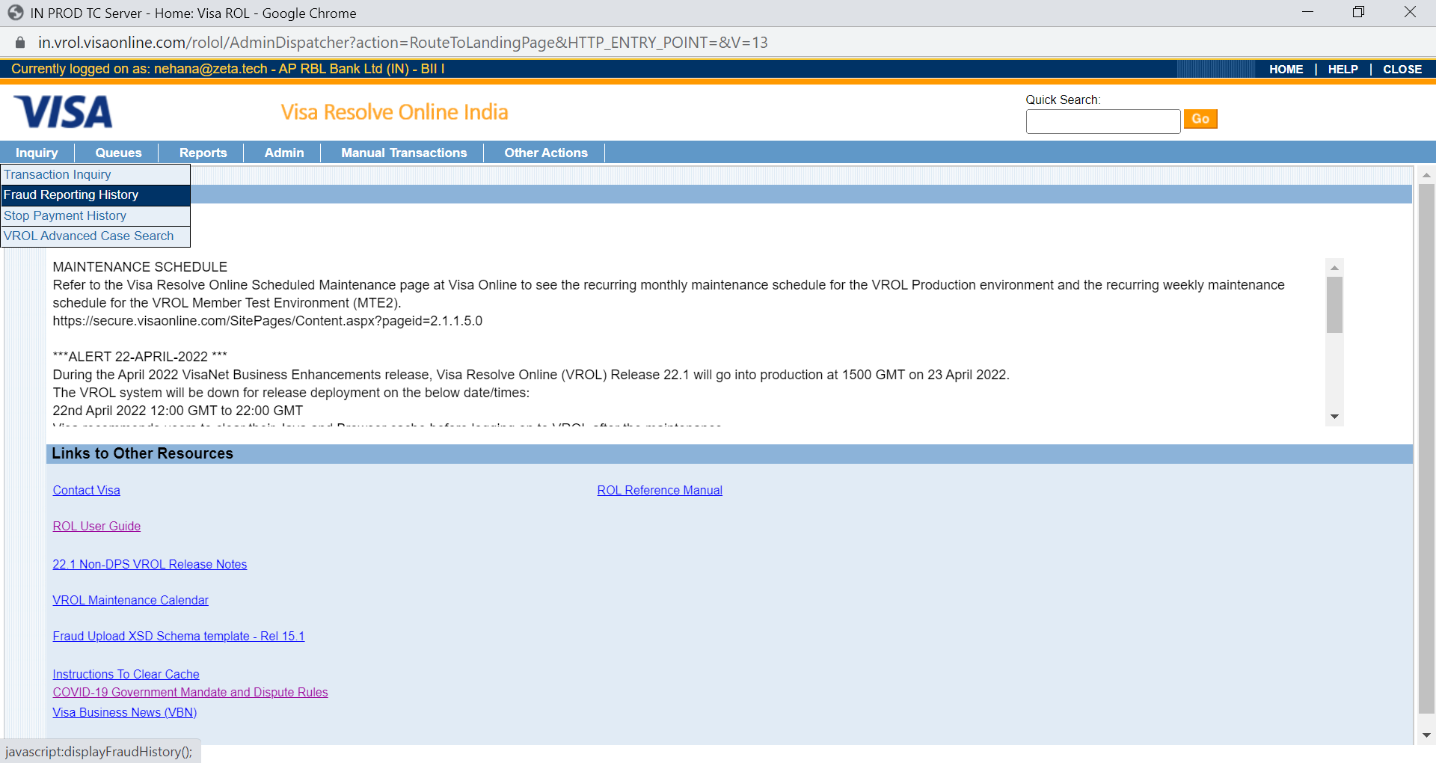
Step 2: Details requested shall be entered as below.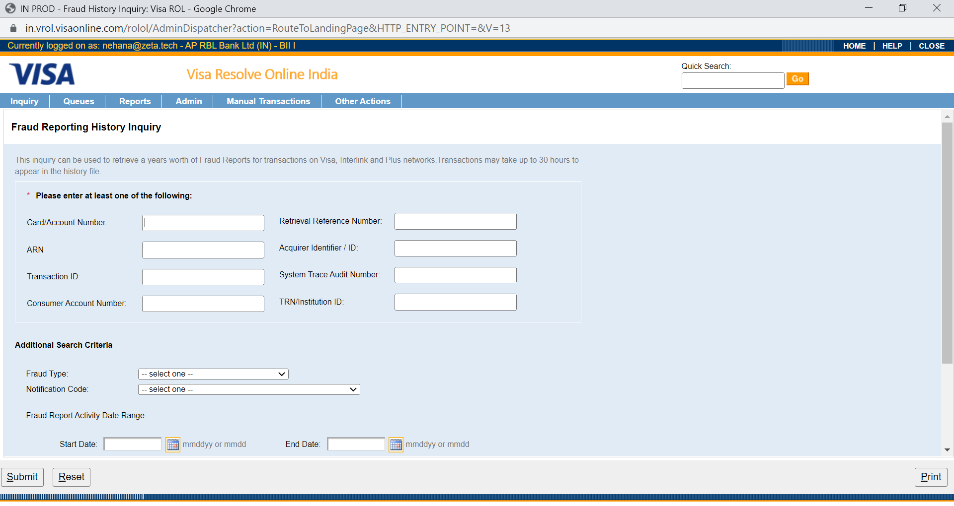
Step 3: Fraud Type shall be selected basis the drop down and transaction Type.
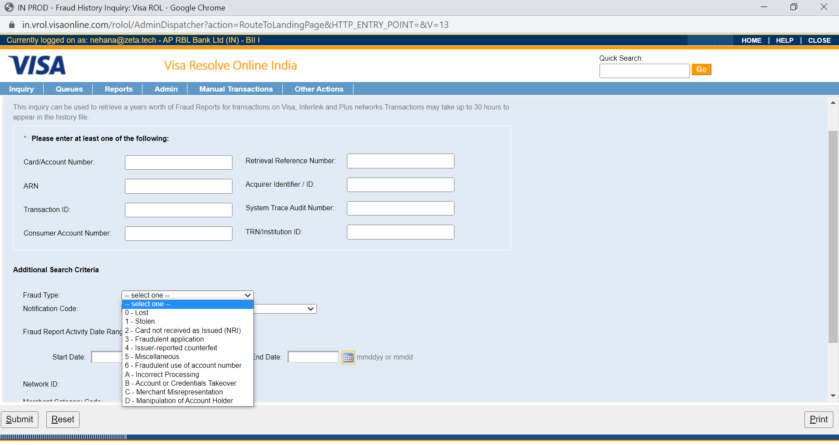
Example:
  - Liability shift, fraud reporting shall be done under “04”
  - Online transaction, fraud reporting shall be reported under “06”.
  - For unattended terminal level transaction, fraud reporting shall be done under “0” or “1”
  - For disputed transaction reported as card no received as issued, Fraud reporting shall be done as “2”

2.1.1 Steps for Exception file listing
Exception Files are documents created by Visa that list credit card numbers that have been reported lost or stolen, are known to be counterfeited, or have other issues that should prevent them from being used.
Step 1: Go to the below section in Visa.
Manual Transactions-à Issuer actions-àException file Negative listing
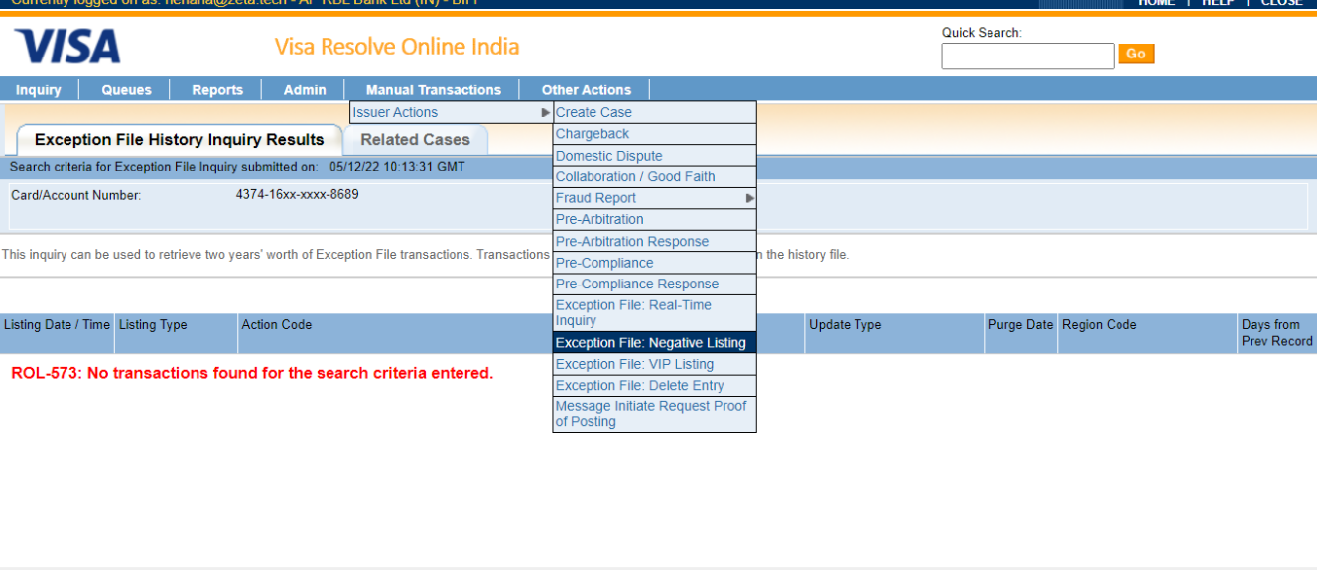
Step 2: Enter the card number to be listed in the Exception file listing screen in Visa UI.
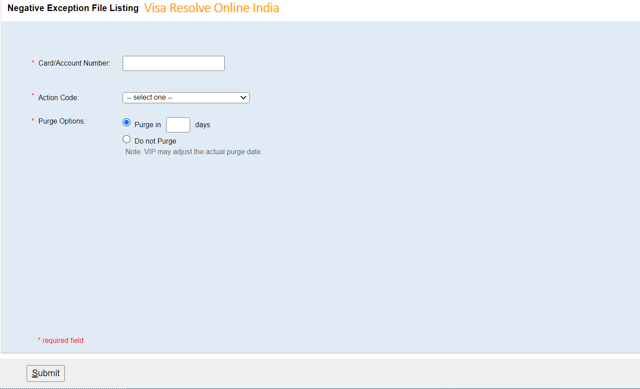
Step 3: Select the action code from the drop down listed in the screen.
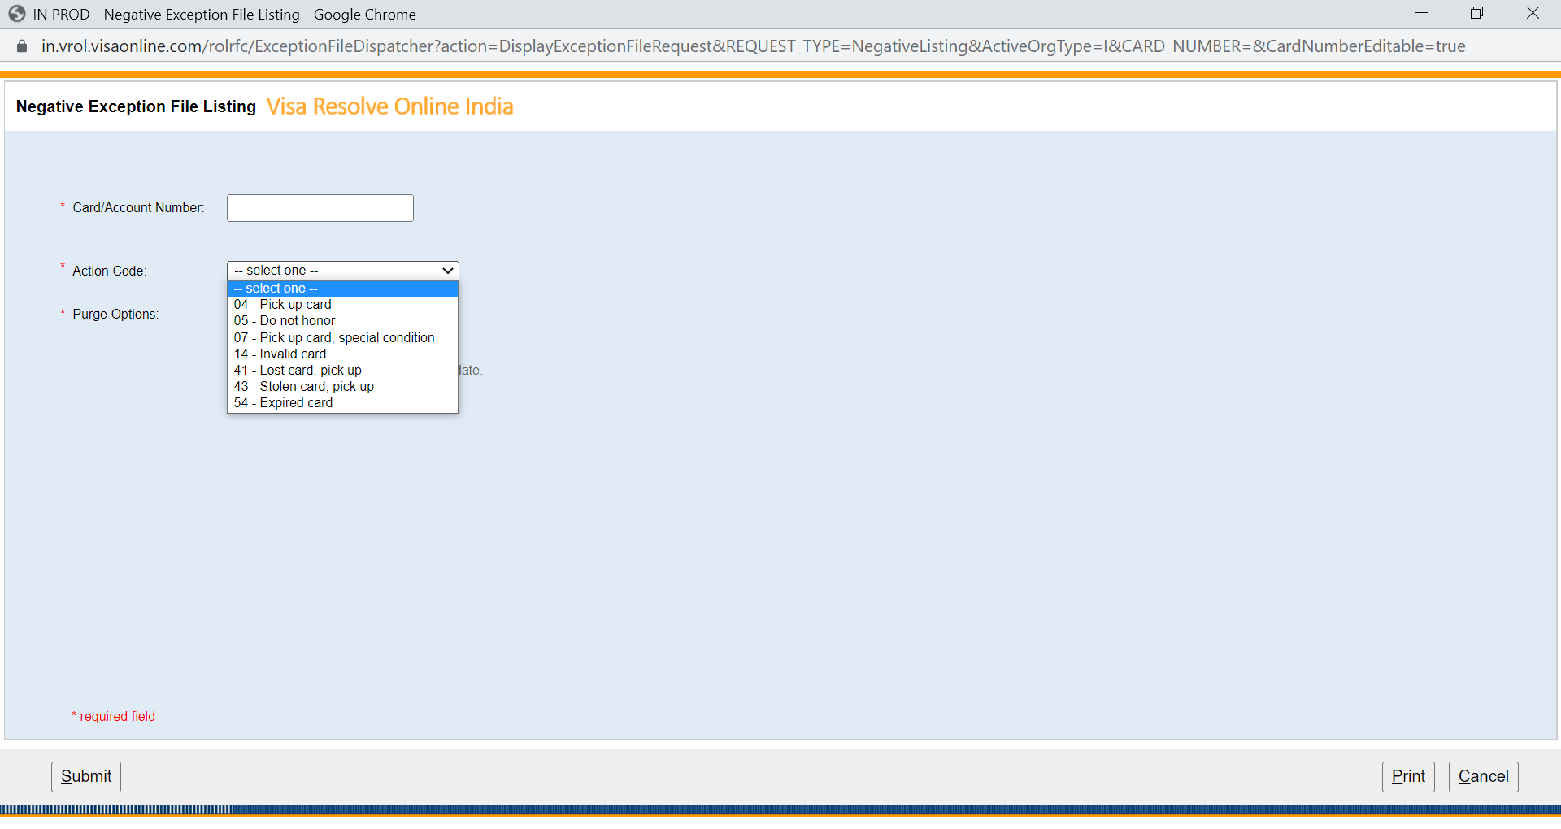
Step 4: enter the purge days till which exception file listing to be done. Normally Exception file listing are done till expiration of the card.
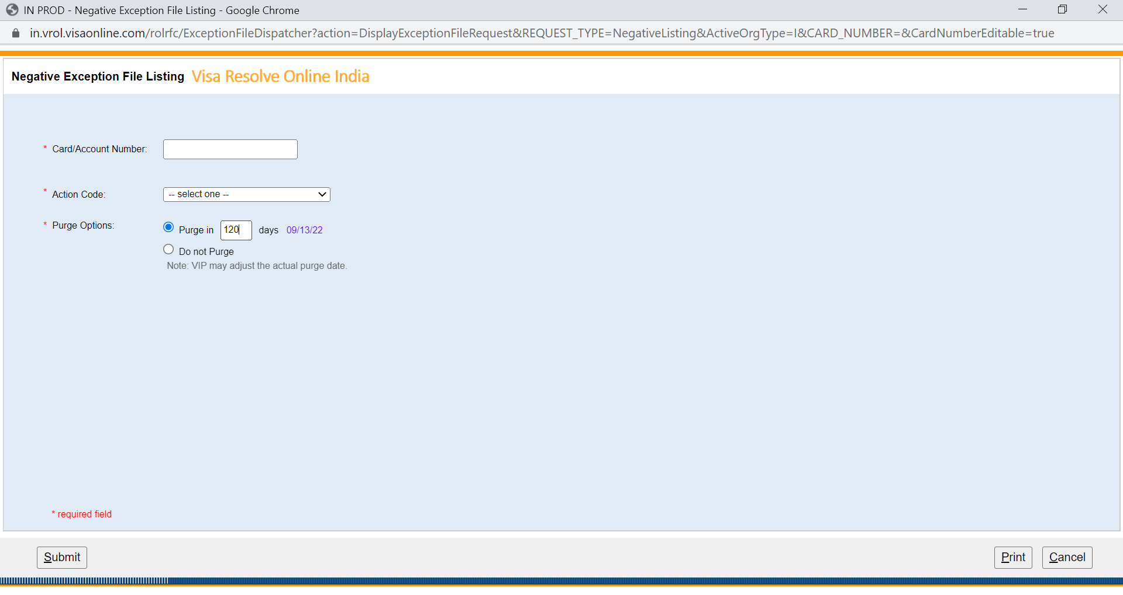

2.2 Dispute Life Cycle with time frames

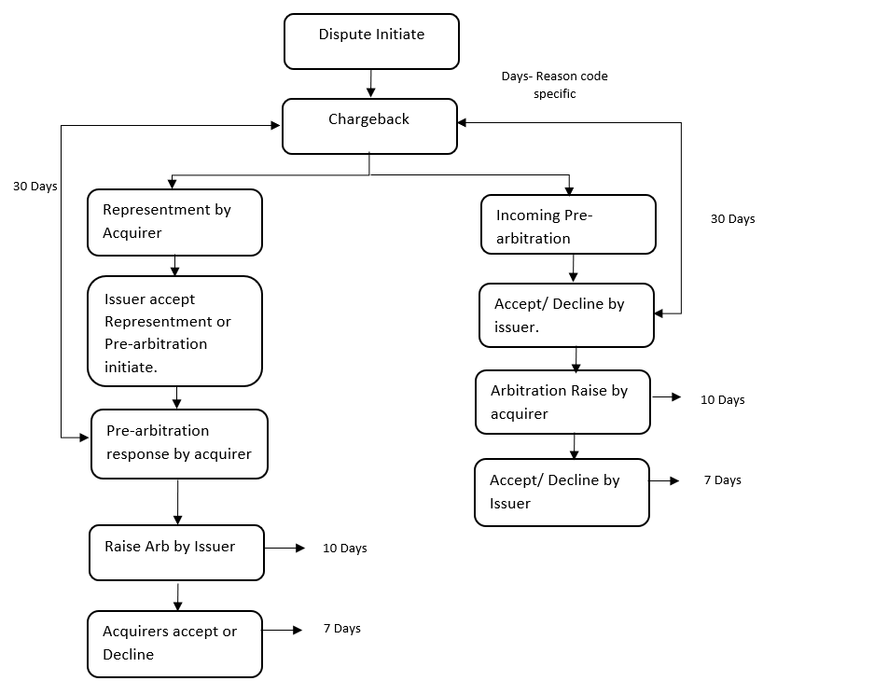

2.3- Accounting Flow for disputes
GL accounting Process to be followed by Zeta team and Bank.
Below section clearly explains the details GL Accounting process against each of dispute category.
- Service-related Disputes -GL Processing Steps for - Provisional credit cases
Step 1: Zeta team to handle the dispute investigation for all the incoming disputes via Customer support team.
Step 2: First level Provisional credit shall be given to the User account basis the chargeback availability details shared by the user.
Step 3: Once the details are available, Provisional credit shall be provided using Dispute upfront credit Option in the Ops centre.
Step 4: End of the day when dispute upfront Provisional credit are provided, Flex cube handoff GL shall be generated by Zeta system and shared with HDFC bank.
Step 5: The flex cube hand off file shall have the sum of consolidated provisional credits provided during the day.
Step 6: The next day, the details of all such provisional credits shall be passed to the Bank GL Team with the details of cases as mentioned below.
EX: Dispute reference number, Transaction Amt, ARN, Merchant name, Dispute credit amount, GL voucher code, Posting type and dispute credit status (Provisional or Permanent)
Step 7: Banks GL processing team shall process all the Debits arising out of provisional credits by passing the below entries.
Dr-------> Provisional Credit AR ___________ (Accounts Receivable- Bank to share flex cube GL account number)
Cr-------> Credit Card Balance AP _____________ (Accounts Payable-Bank to share the flex cube GL Account number).
Step 8: Once chargebacks are raised for the respective cases, Zeta Dispute Ops team to share the details with Banks Dispute Ops Team.
EX: Dispute reference number, Transaction amount, ARN, Merchant name, Dispute credit amount, Chargeback amount, Chargeback raised date, dispute credit status (Provisional or Permanent) and chargeback status.
Step 9: Banks GL processing team shall pass the credit from Network Account to the respective
Step 10: Banks GL processing team to knock off the respective chargeback Credit and provisional credit debits for the chargeback raised cases.
Revised Entry Leg (Bank to handle the same)
Dr-------> Network Account ___________ (Accounts Receivable- Bank to share flex cube GL account number)
Cr-------> Provisional Credit AR ___________ (Accounts Receivable- Bank to share flex cube GL account number)
- Service-related Disputes-For Representment received cases and dispute closed against the User-Provisional credit
Step 1: Once the representment is received, Zeta Ops team shall share the details of representment received to HDFC Dispute processing team.
EX: Dispute reference number, Transaction amount, ARN, Merchant name, Dispute credit amount, Chargeback amount, Chargeback raised date, dispute credit status (Provisional or Permanent) and chargeback status
Step 2: HDFC GL processing team shall process the representment debit to Representment AR by crediting the Network Account.
Cr-------> Network Account ___________ (Accounts Receivable- Bank to share flex cube GL account number)
Dr-------> Representment Account _____________ (Bank to share the flex cube GL Account number for documentation purpose).
Step 3: Once the Dispute is closed against the customer and no further dispute rights exist, Zeta Ops team shall reverse the Provisional credit and share the details with HDFC GL processing team.
EX: Dispute reference number, Transaction amount, ARN, Merchant name, Dispute credit amount, Chargeback amount, Chargeback raised date, dispute credit status (Provisional or Permanent), chargeback status and Dispute status.
Step 4: HDFC GL processing team shall pass the respective Credits to Provisional Credit Debit AR and Debit Credit card balance AP.
Reversal of Provisional Credit
Cr-------> Provisional credit AR___________ (Bank to share flex cube GL account number)
Dr-------> Credit card balance Account_____________ (Bank to share the flex cube GL Account number).
Step 5: HDFC GL processing team shall knock off by passing the debit to Provisional Credit Debit AR and credit Representment Debit AR.
GL Knock Off entries between Representment AR and Provisional credit AR
Dr-------> Provisional credit Account_____________ (Bank to share the flex cube GL Account number).
Cr-------> Representment Account___________ (Bank to share flex cube GL account number)
- Service-related Disputes -For Representment received cases and dispute closed in favour of the User- Provisional credit
Step 1: Once the representment is received, Zeta Ops team shall share the details of representment received to HDFC GL processing team.
EX: Dispute reference number, Transaction amount, ARN, Merchant name, Dispute credit amount, Chargeback amount, Chargeback raised date, dispute credit status (Provisional or Permanent) and chargeback status
Step 2: HDFC GL processing team shall process the representment debit to Representment AR by crediting the Network Account.
Dr-------> Representment Account___________ (Bank to share flex cube GL account number)
Cr-------> Network Account_____________ (Bank to share the flex cube GL Account number).
Step 3: Once the Dispute is closed in favour of the customer, Zeta Ops team shall reverse the Provisional credit and Provide Permanent credit.
Step: 4 Once permanent provided details of reversal and Permanent credit share be shared with HDFC GL processing team.
EX: Dispute reference number, Transaction amount, ARN, Merchant name, Dispute credit amount, Chargeback amount, Chargeback raised date, dispute credit status (Provisional or Permanent), chargeback status and Dispute status.
Step 4: For Provisional credits reversal, HDFC GL processing team shall process the GL to pass the respective Credits to Provisional Credit Debit AR and Debit Credit card balance AP.
Dr-------> Credit card Balance account___________ (Bank to share flex cube GL account number)
Cr-------> Provisional credit Account_____________ (Bank to share the flex cube GL Account number).
Step 5: For Permanent credit provided, HDFC GL processing team shall pass the debit to permanent Credit Debit AR and Credit, Credit card balance AR.
Cr-------> Credit card Balance account___________ (Bank to share flex cube GL account number)
Dr-------> Permanent credit Account_____________ (Bank to share the flex cube GL Account number).
Step 6: The final leg, HDFC Team shall pass the knock off GL, crediting the representment AR and debit Pre-Arbitration/Arbitration credit from the respective AC________.

Revised entries
Cr-------> Representment Account___________ (Bank to share flex cube GL account number)
Dr-------> Network Account_____________ (Bank to share the flex cube GL Account number).
Service-related Disputes-For No representment received cases and dispute closed in favour of the User-Provisional Credit
Step 1: Once the Dispute is closed in favour of the customer, Zeta Ops team shall reverse the Provisional credit and Provide Permanent credit to the user account by updating the status in the dispute workflow system.
Step 2: Once Permanent credit are provided, Zeta System shall generate the Flex cube GL hands off file shall be shared with HDFC GL processing team.
EX: Dispute reference number, Transaction amount, ARN, Merchant name, Dispute credit amount, Chargeback amount, Chargeback raised date, dispute credit status (Provisional or Permanent), chargeback status and Dispute status.
Step 3: For provisional credit reversal, HDFC GL processing team shall process the GL to pass the respective Credits to Provisional Credit Debit AR and Debit Credit card balance AP.
Dr-------> Credit card Balance account___________ (Bank to share flex cube GL account number)
Cr-------> Provisional credit Account_____________ (Bank to share the flex cube GL Account number).
Step 4: For the Permanent credit provided, HDFC Team shall process the GL to debit the Permanent credit AR and Credit the Credit Card balance AP.
Cr-------> Credit card Balance account___________ (Bank to share flex cube GL account number)
Dr-------> Permanent credit Account_____________ (Bank to share the flex cube GL Account number).
Step 5: For the Credit exception in the provisional credit AR, HDFC GL processing team shall be knock off the credit with the Debit available in the Permanent credit AR.
Dr-------> provisional credit account___________ (Bank to share flex cube GL account number)
Cr-------> Permanent credit Account_____________ (Bank to share the flex cube GL Account number).
- GL Processing Steps for Service-related Disputes- No Provisional credit cases (Exceptional Cases)- Recommendation from bank to give credit and minimalize the scenario.
Step 1: Zeta team to handle the dispute investigation for all the incoming disputes via Customer support team.
Step 2: Once chargeback are raised for the respective cases, Zeta Dispute Ops team to share the details with Banks GL processing team.
EX: Dispute reference number, Transaction amount, ARN, Merchant name, Dispute credit amount, Chargeback amount, Chargeback raised date, dispute credit status (Provisional or Permanent) and chargeback status
Step 3: Banks GL processing team shall pass the Chargeback credit funds to the respective Credit AP AC_________ by debiting the respective Network account.
Cr-------> Chargeback Payable Account ___________ (Bank to share flex cube GL account number)
Dr-------> Network Account _____________ (Bank to share the flex cube GL Account number).
- Service-related Disputes-For Representment received cases and dispute closed against the User- No provisional credit.
Step 1: Once the representment is received, Zeta Ops team shall share the details of representment received to HDFC GL processing team.
EX: Dispute reference number, Transaction amount, ARN, Merchant name, Dispute credit amount, Chargeback amount, Chargeback raised date, dispute credit status (Provisional or Permanent) and chargeback status
Step 2: HDFC GL processing team shall process the representment debit to Representment AR by crediting the Network Account.
Cr-------> Network account___________ (Bank to share flex cube GL account number)
Dr-------> Representment account _____________ (Bank to share the flex cube GL Account number).
Step 3: Once the Dispute is closed against the customer and no further dispute rights exist, Zeta Ops team Update the distance in the Workflow system and share the details with HDFC GL processing team.
EX: Dispute reference number, Transaction amount, ARN, Merchant name, Dispute credit amount, Chargeback amount, Chargeback raised date, dispute credit status (Provisional or Permanent), chargeback status and Dispute status.
Step 4: HDFC GL processing team shall knock off by passing the debit to Chargeback Credit AP AC_______ and credit Representment Debit AR.
Cr-------> Representment account___________ (Bank to share flex cube GL account number)
Dr-------> Chargeback payable account _____________ (Bank to share the flex cube GL Account number).
- Service-related Disputes-For Representment received cases and dispute closed in favour of the User
Step 1: Once the representment is received, Zeta Ops team shall share the details of representment received to HDFC GL processing team.
EX: Dispute reference number, Transaction amount, ARN, Merchant name, Dispute credit amount, Chargeback amount, Chargeback raised date, dispute credit status (Provisional or Permanent) and chargeback status
Step 2: HDFC GL processing team shall process the representment debit to Representment AR by crediting the Network Account.
Dr-------> Representment account___________ (Bank to share flex cube GL account number)
Cr-------> Network account _____________ (Bank to share the flex cube GL Account number).
Step 3: Once the Dispute is closed in favour of the customer, Zeta Ops team shall Provide Permanent credit in the Workflow by updating the dispute status.
Step 4: Once permanent credit, Permanent credit details shall be shared with HDFC GL processing team.
EX: Dispute reference number, Transaction amount, ARN, Merchant name, Dispute credit amount, Chargeback amount, Chargeback raised date, dispute credit status (Provisional or Permanent), chargeback status and Dispute status.
Step 5: For Permanent credit provided, HDFC GL processing team shall pass the debit to permanent Credit Debit AR and credit, Credit card balance AR.
Dr-------> Permanent Credit account___________ (Bank to share flex cube GL account number)
Cr-------> Credit card balance account _____________ (Bank to share the flex cube GL Account number).
Step 6: Second leg-The chargeback credit to be knocked off with Debit exception available in Permanent credit AR.
Dr-------> Chargeback Payable A/C___________ (Bank to share flex cube GL account number)
Cr-------> Permanent Credit Account _____________ (Bank to share the flex cube GL Account number).
Step 7: The final leg, HDFC Team shall pass the knock off GL, crediting the representment AR and debit Pre-Arbitration/Arbitration credit from the respective AC________.
Revised Leg
Dr-------> Network Account_____________ (Bank to share the flex cube GL Account number).
Cr-------> Representment Account___________ (Bank to share flex cube GL account number)
- Service-related Disputes-For No representment received cases and dispute closed in favour of the User. ( No Provisional credit Provided)
Step 1: Once the Dispute is closed in favour of the customer, Zeta Ops team shall Provide Permanent credit to the user account by updating the status in the dispute workflow system.
Step 2: Once Permanent credits are provided, Zeta System shall generate the Flex cube GL hands off file shall be shared with HDFC GL processing team.
EX: Dispute reference number, Transaction amount, ARN, Merchant name, Dispute credit amount, Chargeback amount, Chargeback raised date, dispute credit status (Provisional or Permanent), chargeback status and Dispute status.
Step 3: For the Permanent credit provided, HDFC Team shall process the GL to debit the Permanent credit AR and Credit the Credit Card balance AP.
Dr-------> Permanent Credit Account___________ (Bank to share flex cube GL account number)
Cr-------> Credit Card Account_____________ (Bank to share the flex cube GL Account number).
Step 5: For the Debit exception in the Permanent credit AR, HDFC GL processing team shall knock off the credit available in the Chargeback AC _____ with the Debit available in the Permanent credit AR.
Dr-------> Chargeback payable Account___________ (Bank to share flex cube GL account number)
Cr-------> Permanent Credit Account_____________ (Bank to share the flex cube GL Account number).
- Unauthorized-Dispute Rights exists-GL Processing Steps
Step 1: Zeta team to handle the dispute investigation for all the incoming disputes via Customer support team.
Step 2: First level permanent credit shall be given to the User account basis the chargeback availability details shared by the user.
Step 3: Once the details are available, Permanent credit shall be provided using Dispute upfront credit Option in the Ops centre.
Step 4: End of the day when dispute upfront Permanent credit are provided, Flex cube handoff GL shall be generated by Zeta system and shared with HDFC bank.
Step 5: The flex cube hand off file shall have the sum of consolidated permanent credits provided during the day.
Step 6: The next day, the details of all such permanent credits shall be passed to the Bank GL Team with the details of cases as mentioned below.
EX: Dispute reference number, Transaction Amt, ARN, Merchant name, Dispute credit amount, GL voucher code, Posting type and dispute credit status (Permanent)
Step 7: Banks GL processing team shall process all the Debits arising out of Permanent credits by passing the below entries.
Dr-------> Permanent Credit AR ___________ (Bank to share flex cube GL account number)
Cr-------> Credit Card Balance AP _____________ (Bank to share the flex cube GL Account number).
Step 8: Once chargeback are raised for the respective cases, Zeta Dispute Ops team to share the details with Banks GL processing team.
EX: Dispute reference number, Transaction amount, ARN, Merchant name, Dispute credit amount, Chargeback amount, Chargeback raised date, dispute credit status (Provisional or Permanent) and chargeback status
Step 9: Banks GL processing team to knock off the respective chargeback Credit and Permanent credit debits for the chargeback raised cases.
Revised Leg
Dr-------> Network Account_____________ (Bank to share the flex cube GL Account number).
Cr-------> Permanent Credit account___________ (Bank to share flex cube GL account number)

- Unauthorized-Dispute Rights exists -Pre-arbitration received cases and dispute closed against the User (Exception cases Like credit processed or Customer accepting the dispute)
Step 1: Once the Pre arbitration is received and accepted, Zeta Ops team shall share the details of Pre-arbitration accepted to HDFC GL processing team.
EX: Dispute reference number, Transaction amount, ARN, Merchant name, Dispute credit amount, Chargeback amount, Chargeback raised date, dispute credit status (Provisional or Permanent) and chargeback status
Step 2: HDFC GL processing team shall process the Pre-Arbitration debit to Pre-Arbitration debit by crediting the Network Account.
Revised Leg
No Entries required as there is no account to park the pre arbitration debit.
Step 3: Once the Dispute is closed against the customer and no further dispute rights exist, Zeta Ops team shall reverse the Permanent credit and share the details with HDFC GL processing team.
EX: Dispute reference number, Transaction amount, ARN, Merchant name, Dispute credit amount, Chargeback amount, Chargeback raised date, dispute credit status (Provisional or Permanent), chargeback status and Dispute status.
Step 4: HDFC GL processing team shall process the GL to pass the respective Credits to Permanent Credit Debit AR and Debit Credit card balance AP.
Dr-------> Credit card account___________ (Bank to share flex cube GL account number)
Cr-------> Permanent Credit account_____________ (Bank to share the flex cube GL Account number).
Step 5: HDFC GL processing team shall knock off by passing the debit to Permanent Credit Debit AR and credit where Per arbitration Debit is parked.
Cr-------> Network Account___________ (Bank to share flex cube GL account number)
Dr-------> Permanent Credit account_____________ (Bank to share the flex cube GL Account number).
- Unauthorized-Dispute Rights exists- Pre-Arbitration received cases and dispute closed in favour of the User.
Step 1: Once the Dispute is closed in favour of the customer, Zeta Ops team shall reverse the initial Permanent credit and Provide Final Permanent credit to the user account by updating the status in the dispute workflow system.
Step 2: Once final Permanent credit are provided, Zeta System shall generate the Flex cube GL hands off file shall be shared with HDFC GL processing team.
EX: Dispute reference number, Transaction amount, ARN, Merchant name, Dispute credit amount, Chargeback amount, Chargeback raised date, dispute credit status (Provisional or Permanent), chargeback status and Dispute status.
Step 3: For initial Permanent credit reversal, HDFC GL processing team shall process the GL to pass the respective Credits to Permanent Credit Debit AR and Debit Credit card balance AP.
Dr-------> Credit card account___________ (Bank to share flex cube GL account number)
Cr-------> Permanent Credit account_____________ (Bank to share the flex cube GL Account number).
Step 4: For the Final Permanent credit provided, HDFC Team shall process the GL to debit the Final Permanent credit AR and Credit the Credit Card balance AP.
Cr-------> Credit card account___________ (Bank to share flex cube GL account number)
Dr-------> Permanent Credit account_____________ (Bank to share the flex cube GL Account number).
Step 5: For the Final Credit exception in the Permanent credit AR, HDFC GL processing team shall knock off the credit with the Debit available in the Permanent credit AR.
- Unauthorized-Dispute Rights exists -Pre Arbitration received cases and Write Off due to Operational error(Exceptional Cases)
Step 1: Zeta Ops to obtain approval for taking the Write off for the cases and Dispute shall be closed in favour of the customer.
Step 2: Zeta Ops team shall reverse the initial Permanent credit and Provide Final Permanent credit to the user account by updating the status in the dispute workflow system.
Step 3: Once final Permanent credit are provided, Zeta System shall generate the Flex cube GL hands off file shall be shared with HDFC GL processing team. Zeta Ops team shall share the details to the HDFC team with fields in an Excel.
EX: Dispute reference number, Transaction amount, ARN, Merchant name, Dispute credit amount, Chargeback amount, Chargeback raised date, dispute credit status (Provisional or Permanent), chargeback status and Dispute status.
Step 3: For initial Permanent credit reversal, HDFC GL processing team shall process the GL to pass the respective Credits to Permanent Credit Debit AR and Debit Credit card balance AP.
Dr-------> Credit card account___________ (Bank to share flex cube GL account number)
Cr-------> Permanent Credit account_____________ (Bank to share the flex cube GL Account number).
Step 4: For the Final Permanent credit provided, HDFC Team shall process the GL to debit the Final Permanent credit AR and Credit the Credit Card balance AP.
Cr-------> Credit card account___________ (Bank to share flex cube GL account number)
Dr-------> Permanent Credit account_____________ (Bank to share the flex cube GL Account number).
Step 5: For the Final Credit exception in the Permanent credit AR, HDFC GL processing team shall b knock off the credit with the Debit available in the Permanent credit AR.
Step 6: For Pre arbitration/Arbitration acceptance due incorrect action, the debit shall be received at the Network account. The debit shall be knocked off by debiting the P/L account and credit the respective AC_____ where the debit is parked.
Revised Leg
Dr-------> P/L Account_____________ (Bank to share the flex cube GL Account number).
Cr-------> Network Account___________ (Bank to share flex cube GL account number)
- Transaction Level Write Off cases(Small Balance Write off)
Step 1: For transaction level write off eligible cases, Zeta Ops to select the write off in the workflow.
Step 2: Post write off approval in the workflow, Zeta system shall create a Flex cube GL hands off file shall be shared with HDFC GL processing team.
Step 3: Once write off Permanent credit are provided, Zeta System shall generate the Flex cube GL
Step 4: Zeta dispute Ops team shall provide the details of write off cases in an excel with below fields.
EX: Dispute reference number, Transaction amount, ARN, Merchant name, Dispute credit amount and Dispute status.
Step 5: For the write off Permanent credit provided, HDFC Team shall process the GL to debit the Write off AR and Credit the Credit Card balance AP.
Cr-------> Credit card Balance Account___________ (Bank to share flex cube GL account number)
Dr-------> (Permanent Credit) _____________ (Bank to share the flex cube GL Account number).
Second leg
Cr-------> Permanent Cr Account___________ (Bank to share flex cube GL account number)
Dr-------> Mishandled GL)_____________ (Bank to share the flex cube GL Account number).

- Exception and STIP related Level Write Off cases
Step 1: For Exception and STIP related write off eligible cases, Zeta Ops to select the write off in the workflow.
Step 2: Post write off approval in the workflow, Zeta system shall create a Flex cube GL hands off file shall be shared with HDFC GL processing team.
Step 3: Once write off Permanent credit are provided, Zeta System shall generate the Flex cube GL
Step 4: Zeta dispute Ops team shall provide the details of write off cases in an excel with below fields.
EX: Dispute reference number, Transaction amount, ARN, Merchant name, Dispute credit amount and Dispute status.
Step 5: For the write off Permanent credit provided, HDFC Team shall process the GL to debit the Write off AR and Credit the Credit Card balance AP.
Cr-------> Credit card Balance Account___________ (Bank to share flex cube GL account number)
Dr-------> (Permanent Credit) _____________ (Bank to share the flex cube GL Account number).
Second leg
Cr-------> Permanent Cr Account___________ (Bank to share flex cube GL account number)
Dr-------> Mishandled GL)_____________ (Bank to share the flex cube GL Account number).

- GL Processing Steps for Unauthorized-No Dispute Rights exists- FRM Referral cases
Step 1: Zeta team to handle the dispute investigation for all the incoming disputes via Customer support team.
Step 2: Zeta Ops to refer the dispute to HDFC FRM Team by providing the provisional credit.
Step 3: Provisional credit shall be provided using Dispute upfront credit Option in the Ops centre.
Step 4: End of the day for all dispute upfront Provisional credit are provided, Flex cube handoff GL shall be generated by Zeta system and shared with HDFC bank.
Step 5: The flex cube hand off file shall have the sum of consolidated permanent credits provided during the day.
Step 6: The next day, the details of all such provisional credits shall be shared with Bank GL Team with the details of cases as mentioned below.
EX: Dispute reference number, Transaction Amt, ARN, Merchant name, Dispute credit amount, GL voucher code, Posting type and dispute credit status (provisional)
Step 7: Banks GL processing team shall process all the Debits arising out of provisional credits by passing the below entries.
Dr-------> Provisional Credit AR ___________ (Accounts Receivable- Bank to share flex cube GL account number)
Cr-------> Credit Card Balance AP _____________ (Accounts Payable-Bank to share the flex cube GL Account number).
Step 8: Once HDFC FRM team had accepted the case, Banks Team shall share the excel sheet basis which Zeta team shall provide permanent credit to the cases by reversing the provisional credit given. Once Permanent are provided, the list of all such cases shall be shared with the below details to banks HDFC GL processing team.
EX: Dispute reference number, Transaction amount, ARN, Merchant name, Dispute credit amount, dispute credit status (Provisional or Permanent) and Dispute status.
Step 9 : For Provisional credits reversal, HDFC GL processing team shall process the GL to pass the respective Credits to Provisional Credit Debit AR and Debit Credit card balance AP.
Cr-------> Provisional credit Account___________ (Bank to share flex cube GL account number)
Dr-------> Credit card balance_____________ (Bank to share the flex cube GL Account number).
Step 10: For Permanent credit provided, HDFC GL processing team shall pass the debit to FRM Debit AR(Bank to share the AC_______ details) and credit, Credit card balance AR.
First Leg
Cr-------> Credit Card Account___________ (Bank to share flex cube GL account number)
Dr-------> Permanent Credit Account_____________ (Bank to share the flex cube GL Account number).
Final Leg- HDFC GL Recon Ops team shall process the entries for the below.
Cr-------> Permanent Credit Account ___________ (Bank to share flex cube GL account number)
Dr-------> Insurance Account_____________ (Bank to share the flex cube GL Account number).
Step 11: FRM declined cases, Zeta Ops shall reverse the Provisional credit already provided to the User account.
Dr-------> Credit Card Balance AP _____________ (Accounts Payable-Bank to share the flex cube GL Account number).
Cr-------> Provisional Credit AR ___________ (Accounts Receivable- Bank to share flex cube GL account number)

2.4- Pre-Compliance (Post MVP).

    - For dispute raised on a transaction which doesn’t have the chargeback rights shall be checked for the pre compliance as per the network guidelines.
    - Support centre shall have the dispute raised basis the customer dispute and assign to Ops centre for investigation.
    - Ops centre agent shall investigate the case and check if dispute raised does have chargeback rights. If chargeback rights do not exist, then the ops agent shall check for pre compliance rights.
    - If pre compliance rights exist, Ops agent shall provide provisional credit and have the pre compliance in the network and check for response in association system.
    - If Pre compliance is declined, the Ops agent shall check for compliance escalation basis the merit of the case.
    - If pre compliance is accepted, Ops agent shall reverse the provisional credit and provide permanent credit to the customer and update the ticket as appropriate.

- Pre-compliance Flowchart
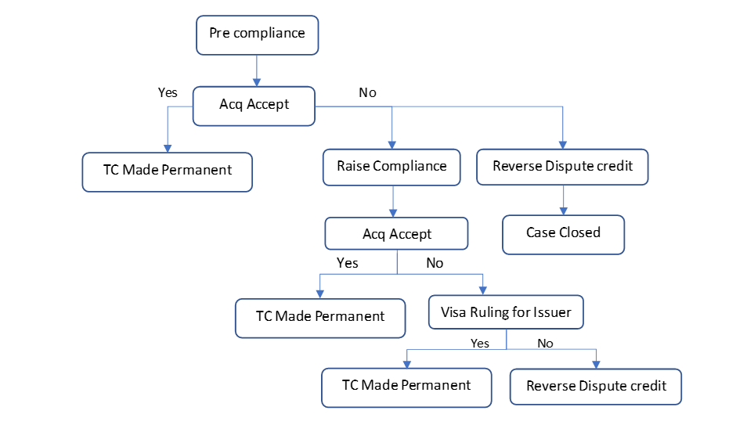

2.5- Good Faith process(Post MVP).
    - Good faith process raised for the request received from the customer which are outside the dispute guidelines.
    - Reasons like Disputed transaction was Out time frame, required documents not shared within dispute time frame etc…for which good faith process shall be initiated with the member bank post concurrence from the HDFC bank.
    - For good faith raised on a transaction which doesn’t have the chargeback rights shall not be provided with Provisional credit/ Permanent credit unless recommended by the bank.
    - For any good faith request received by Support centre shall have the case created in the support centre UI and assign to Ops centre for investigation.
    - Ops centre agent shall investigate the case and raise in the network and check for response in association system.
    - If Good faith is accepted, the Ops agent shall arrange for permanent credit and knock off the same with the credit received from the member bank.
    - If Good faith is declined, the Ops agent shall close the case and inform the initiator and update the ticket with the resolution as appropriate.

- 2.6- Annexures

  - MIS for support Centre

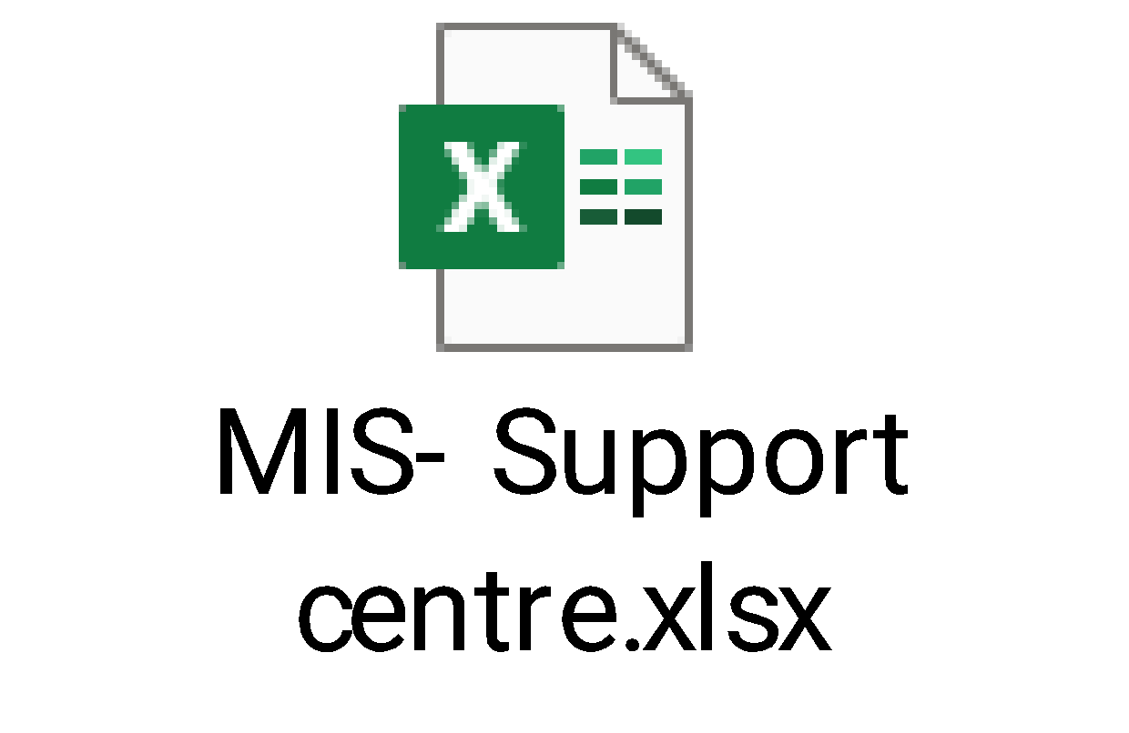
  - Dispute credit summary

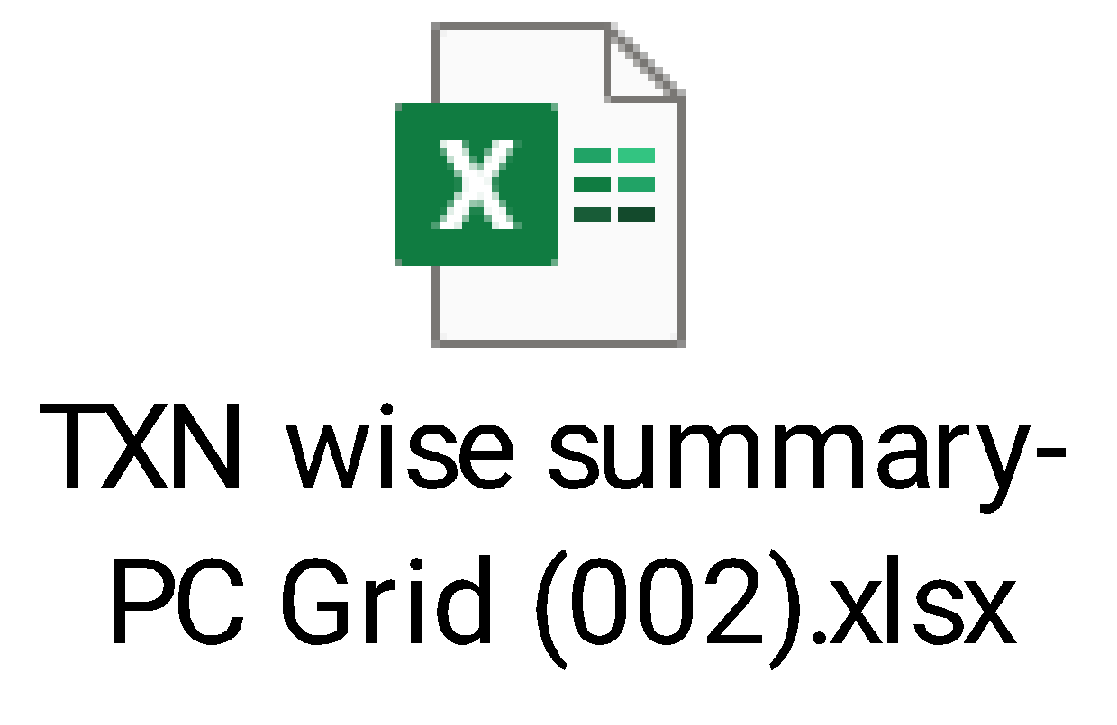

2.7 Reports

Sl. No | Report Name | Credit Account
1 | Case initiated & No action report | To track disputes queued, but no action taken.
2 | Provisional credit/Permanent credit pending report. (Unauthorized dispute) | To track provisional credit/permanent credit processing within 7 days from the dispute date on Unauthorized disputes.
3 | Unauthorized dispute not resolved within 90 days | To track open disputes under reason “Unauthorized transaction” for resolution within 90 days.
4 | Dispute accounting reports | To monitor disputes ageing under various dispute life cycles.
2.8 CPFIR reporting- Regulatory requirement

Section 1- Dispute received intimation
Step 1: All the Unauthorized disputes which are settled should be reported to the RBI within 7 calendar days from the date of dispute notification.
Step 2: If the User disputed transaction is in authorization but not settled, the same must be reported once the transaction is settled to the RBI within 7 calendar days.
Step 3: The report should be prepared in the specified format shared by the RBI (the mandatory fields to be populated without which the report shall not get uploaded in the system.)
Step 4: Zeta Ops team to generate the report on Tuesday and Friday and share this with HDFC bank for uploading into RBI site.
Step 5: Once the Upload is done, Bank shall confirm to Zeta on the status. If there is rejection, the Banks team shall confirm the reason for rejection and the Zeta team shall rectify and share the revised data on the same day.
Step 6: Below are the fields with description to be shared with the Banks team.
Fields required below.
Fields | Description for the fields required
FRAUD_REPORTED_BY_CUSTOMER | "Yes"- If disputed as customer.  "No"- If detected by rule engine by transaction monitoring team.
ATTEMPTED_FRAUD | Should be defaulted as "No"
PAYMENT_TRANSACTION_INSTRUMENT | Should be defaulted as "CRC"
PAYMENT_SYSTEM_CATEGORY | For POS, ECOM and Contactless transactions we need to mention as "CAN".  For ATM transactions- we need to mention as "ATM"
PAYMENT_SYSTEM_INVOLVED | For POS and ECOM, it should be defaulted as "Visa" as Default and Master whenever implemented.  For ATM domestic transactions it should be "NFS  For International transaction it is be mentioned as "EUR".
PAYMENT_CHANNEL_USED | For EComm transaction it should be defaulted to "Int"- Can be identified with ECI -05, 06 and 07.  For POS TXN it should be defaulted to "POS"- can be identified with POS indicator "05"," 02" and "07"  For ATM transaction it should be defaulted as "Atm"- can be identified with "05"
DATE_OF_OCCURRENCE | We need to share the "Transaction date" received in the presentment.
DATE_OF_DETECTION | Date when customer reported the dispute.
DATE_OF_ENTERING_IN_SYSTEM | Date when dispute is initiated in Zeta System
UNIQUE_TRANSCTN_REFERENCE_NO | Unique reference which is not repeated by any other systems.
DOMESTIC_TRANSACTION | Y for domestic  N- for International
CUSTOMER_NAME | Customer Name
CUSTOMER_MOBILE | Customer Mobile
CUSTOMER_EMAIL | Customer email
PAYMENT_GATEWAY_AGGREGATOR_INV | N- Default
THIRD_PARTY_PSP_INVOLVED | N- Default
FRAUDULNT_DESTN_MERCH_NAM | Merchant description
FRAUD_CLOSED | N- First time as No.
SOURCE | Credit Card- Default
REPORTING_DATE | Today- 1 is the reporting date  Ex: If report on 15 Nov 2022, the date to be mentioned as 14 Nov 2022
CASE_NUMBER | CRM reference

Section-2- Closure Intimation
Step 1: All the final status of the reported cases should be provided with details of closure and date when the case was resolved.
Step 2: The Files to be shared by the Zeta Ops team to banks team on fortnightly basis.
Step 3: Zeta Ops team to track the dispute for closure within 90 days from dispute notification date by the user.
Step 4: Below are the fields with description to be shared with Banks team.
Fields required below.
Fields | Description for the fields required
CLOSURE_DATE | Date when dispute is closed
CLOSURE_JUSTIFICATION | How Zeta Ops team had closed the Dispute. Anyone of the below to be selected.  1. Customer Liability.  2. Chargeback Won  3. FRM Accepted.  4. Refund processed.  5. Service dispute  6. Customer accepted

2.9- Unsettled dispute query handling.
- Query raised by the user shall be checked if the transactions are settled.
- If the transactions are Unsettled, the support centre agent shall check for the transaction till the time it gets settled.
- Till the time settlements are received, the support centre team shall have the details sent to CIC team via CRM next to bank to try and cancel the transaction with the merchant.
- Bank shall check and try to cancel the transaction to evidence the effort taken by bank to cancel the transaction.
- Upon settlement received for the transaction, Support centre team shall create the dispute and assign to Ops team for investigation.
- Once the dispute is assigned to Ops team, Ops team shall investigate as per the network guidelines/process agreed with bank.
- For Unsettled transaction till T+9 days, the Support centre team to send in app notification to the user for closure of the query raised.
Open Pointers for Discussion

- Dispute landing in HDFC existing channels. Final approach to be shared by Bank. Discussion on Sprinklers are going on and yet to be finalised.
- GL entry posting for Provisional/ Permanent credit, secure and write off disputes-closed
- Disputes for un-settled transaction-closed
- CRM next App ID creations for Zeta Team.
- Any specific reports required from Zeta from HDFC team-closed.
- Dispute Questionnaire on App/ Support centre.

